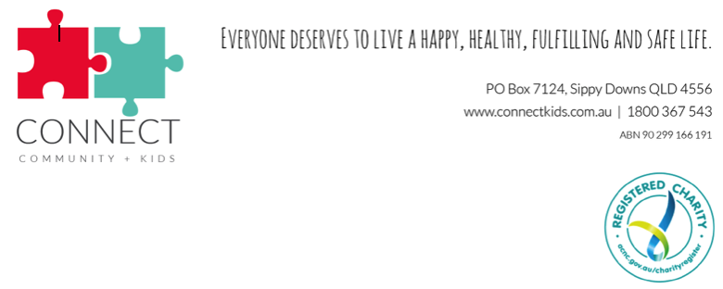

Can you find 2 hours a fortnight, to have some fun?

Then we want you!

Yes just 2 hours is all it takes to change a life!

Connect Community + kids is a broad based mentoring program supporting kids on the coast.

Statistics show that 70% of disadvantaged kids of today will become the next generation of disadvantage, by breaking that cycle we can reduce those statistics by a staggering 30%!

Everyone deserves to live a happy, healthy fulfilling and safe life.

So come on be a kid at heart, have some fun, share some quality one on one time with your own specially matched kid.

This program has been several years in the making and we know it works, so lets support these kids, after all they are our future.

For further information and training
please call 1800 for kids or email us at admin@connectkids.com.au

Come and join the Connect Team

