

FREQUENTLY ASKED QUESTIONS
David Low Way, Retaining Wall Replacement, Sunrise Beach
Project summary
Council contractors will soon commence work on replacing the existing retaining wall along David Low Way in Sunrise Beach.
The aging timber retaining wall has reached the end of its service life and will be upgraded to a durable concrete structure. Designed for low maintenance and long life, the new wall will support the construction of a 3-metre shared pathway, enhancing safety and accessibility for cyclists and pedestrians.
Where is the project located?
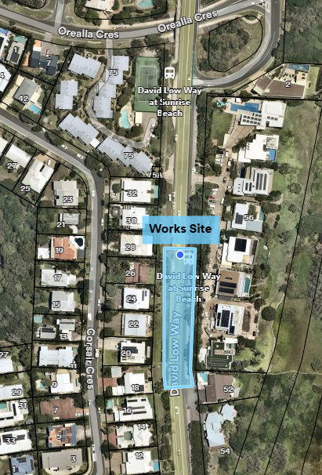
The project is located adjacent to 56 David Low Way and about 200 metres south of the Orealla Crescent Bridge.

How is this project funded?
This project is proudly funded by the Queensland Government’s Local Roads and Community Infrastructure (LRCI) Program, in partnership with Noosa Council.
When will the work start and how long will it take?
Construction is scheduled to commence in early March 2025 and take approximately three (3) months to complete, subject to weather and construction conditions.
What will the work include?
The scope of works includes:
• Excavation
• Installation of piles
• Concrete works
• Landscaping and tree removal
• Replacement of the southern retaining wall
• Associated road and footpath reconstruction
What are the expected vehicle traffic impacts during construction?
Both traffic lanes on David Low Way will remain open throughout the works, allowing vehicles to travel in both directions. However, due to site limitations, some traffic delays are expected.
Emergency Services will be briefed on any changed traffic conditions, prior to and throughout the works.
What are the expected pedestrian traffic impacts during construction?
The pedestrian footpath along David Low Way will be temporarily closed due to the extent of the works. However, alternative pedestrian access will be maintained along David Low Way for the duration of the project.
Will there be any other impacts as a result of the works?
Due to limited on-site space for equipment and materials, Tingira Park will be used as a site compound and will be fenced off for the duration of the works.
What are the working days and hours, and will there be noise impacts?
Works will generally take place from Monday to Saturday, between 7am and 6pm.
While every effort will be made to minimise disruptions, general construction noise will be present during the project. Noise and vibration monitoring will be conducted to help mitigate impacts.
Are any trees being removed as part of the retaining wall replacement?
Some trees will need to be removed to accommodate the new infrastructure.
However, efforts will be made to minimise the impact on existing vegetation. Any necessary tree removals will be carefully assessed, and landscaping rehabilitation will be undertaken upon project completion.

Will work continue over the Easter school holidays?
Construction works are expected to span several weeks and may overlap with some holiday periods. However, works will be scheduled to minimise disruption during school holiday periods wherever possible.
How can community members stay informed about project progress?
Updates will be provided through the Council’s official channels, including the website and social media platforms.
Residents will be notified in advance of any night works or direct property impacts.
For any questions or concerns, please contact us on 07 5329 6500 or via email at mail@noosa.qld.gov.au (subject line: David Low Way Retaining Wall Replacement).

